C:\Users\RobertaC\AppData\Local\Microsoft\Windows\INetCache\Content.Word\ContosoLogo.png

Electronics

# NC460 55”/NC460 60” Feature Comparison

|  |  |  |  |
| --- | --- | --- | --- |
| Category | Feature | NC320 | NC460 |
| Display | Screen Size (in.) | 55 | 60 |
|  | Display Type | LED | LED |
|  | Full HD (1080p) | Yes | Yes |
|  | Min. Resolution 1980x1020 | Yes | Yes |
|  | Motion Clarity Index | 600Hz | 1000Hz |
| Video | Triple XD Engine | Yes | Yes |
|  | Aspect Ration Correction | Yes | Yes |
|  | Smart Color Gradation | Yes | Yes |
|  | Resolution Upscaler | Basic | Plus |
|  | Contrast Optimizer | Yes | Yes |
|  | AV Modes | 3 | 5 |
|  | Picture Modes | 5 | 7 |
|  | Picture Wizard | V1 | V2 |
| 3D Spec | FPR 3D (Cinema 3D) | No | Yes |
|  | Formats | None | 4 |
|  | 2D to 3D | No | Yes |
|  | 3D to 2D | No | Yes |
|  | 3D Modes | None | 5 |
|  | 3D Image Correction | No | Yes |
|  | Format Auto Detection | No | Yes |
|  | 3D Sound Zooming | Yes | Yes |
|  | Dual Play | No | Yes |

# NC460 55” Pricing, Features, and Reviews

Contoso’s connected TV platform gets the nod largely because of its oh-so-simple design that puts seemingly disparate sources of video onto one home screen. Our favorite part of Contoso's smarty-pants user interface hasn't got anything to do with apps, but rather with networking. IntelliShare software displays any video, photo or MP3 file stored on a networked PC, Mac or NAS drive, USB flash drive or HDD, on the home screen - and as a thumbnail image.

Price: $1,349 - $1,370 USD

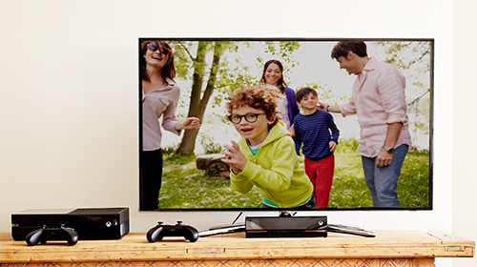

# Special Features

|  |  |  |
| --- | --- | --- |
| Connectivity Suite | Feature | Notes |
|  | Camera | *Sold Separately |
|  | EPS(GI) |  |
|  | Fast View |  |
|  | Input Labeling |  |
|  | e-Manual |  |
|  | e-Streamer |  |
|  | Key Lock |  |

# Reviews

“It's beautifully simple, and file support is huge, though for those wanting an even more comprehensive treatment, Contoso also offers the MediaSync (formerly called OptiPlex) app that adds movie artwork and other data.

“As well as shortcuts to apps and widgets, and full mastery of the TV, a NC ultra-sense controller app puts a live TV picture on a smartphone that mirrors what's playing on the TV. Searches for content across its apps and the web result in source-specific results - and it's a search that can be done on some of Contoso's flagship TVs (such as the **NC460 60”**) by speaking into the NC ultra-sense controller, pointer-style remote control. It works like a treat.”

# NC460 60” Pricing, Features, and Reviews

Anybody still of the opinion that Contoso merely slavishly follows its rivals is very much mistaken.

As well as going completely its own way with 3D, by introducing the passive 3D format, Contoso Electronics is also looking set to beat its competitors to the big-screen immersive HD 3D TV punch. More pertinently for this review, unlike the others, Contoso includes at the top of its TV range models that use direct rather than edge LED lighting in a bid to deliver truly premium performance.

Price: $3,749 - $4,999 USD

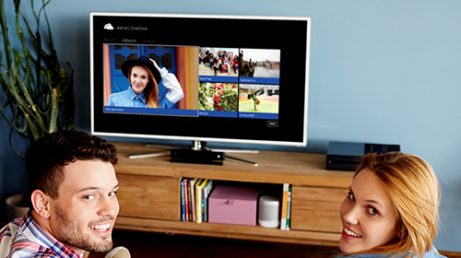

# Special Features

|  |  |  |
| --- | --- | --- |
| Connectivity Suite | Feature | Notes |
|  | Camera | *Sold Separately |
|  | EPS(GI) |  |
|  | Fast View |  |
|  | Input Labeling |  |
|  | e-Manual |  |
|  | e-Streamer |  |
|  | Key Lock |  |

# Reviews

“Not that the NC460 60” just relies on its direct LED lighting and sensational design for its appeal, though. A huge feature list kicks off with passive 3D support, complete with 5 pairs of glasses - which is, of course, a robust salute at the growing trend for active 3D TVs not to supply any free 3D glasses at all.

The NC460 60” is also extremely multimedia savvy, handling an expansive range of multimedia file formats from USB devices or a connected computer. What's more, unusually for the TV world, this computer can just as easily be an Apple Mac as a PC.

Contoso's new NanoSync also lets you connect - wirelessly if you wish - to Contoso's Smart TV platform, which this year has benefited from a substantial rise in content, big improvements in stability, and a slinky new interface.”